Design and Implementation of adder using Ultra Low Voltage CMOS Logic style
C.Kishore Kumar¹ and P.Sivaranjani²
¹Department of Electronics and Communication Engineering,
Kongu Engineering College, Perundurai, Erode, Tamil Nadu, India.
kishorekumar.c2@gmail.com
²Senior lecturer,Department of Electronics and Communication Engineering,
Kongu Engineering College, Perundurai, Erode, Tamil Nadu, India.
Sivaranjani@kongu.ac.in

Abstract— A static CMOS inverter does not dissipate power during the absence of transients on the input. During a transient on the input, there will be a time period in which both the NMOS Transistor and PMOS Transistor will conduct, causing a short circuit to flow from supply to ground for an inverter without load. For a CMOS circuit, the total power dissipation includes dynamic and static components during the active mode of operation. To overcome the drawback of Complementary inverter, the ULV inverters are used in design. The dynamic power consumption is reduced significantly with reduced supply voltage. The static power consumption is more dependent on the transistor threshold voltage. Scaling the supply voltage and threshold voltage reduces the dynamic power dissipation and static power dissipation respectively. In order to achieve high performance for low power consideration, the threshold voltage is scaled along with the supply voltage. The power consumption depends on the recharge voltage and the supply voltage. Therefore optimizing the supply voltage and recharge voltage results in reduced power consumption. In Ultra Low Voltage Low Power CMOS Inverter the offset voltage is scaled along with the threshold voltage. The Ultra Low Voltage Inverter is configured to low power compared to that compared to that of a complementary inverter. A complementary inverter is designed using Tanner EDA Tool. The complementary inverter is used as the basic module for the design of the full adder. The power consumed by the full adder which is designed using the complementary inverter is calculated. Similarly, the Ultra Low Voltage Inverter is designed in Tanner EDA Tool. The Ultra Low Voltage Inverter is used as the basic module for the design of the full adder. The power consumed by the full adder which is designed using the Ultra Low Voltage Inverter is calculated. The objective is to prove that the power consumed by the Ultra Low Voltage Inverter is lower than that of the complementary inverter. Thus, the Ultra Low Voltage Inverter is configured to operate at low power compared to that of the complementary inverter. The logic presented here are designed for 90nm process using Tanner EDA Tool.
.
- Introduction
The most fundamental and effective approach to reduce power consumption in CMOS logic is to lower the supply voltage. For a CMOS circuit, the total power dissipation includes dynamic and static components during the active mode of operation. The dynamic power consumption is reduced significantly with reduced supply voltage. The static power consumption is more dependent on the transistor threshold voltage. However, scaling the supply voltage has an adverse effect of the performance of the circuit, i.e. it could lead to a severe penalty in circuit speed. Power savings can also be achieved by a number of architectural solutions. In order to achieve high performance for low power consideration, the threshold voltage is scaled along with the supply voltage [8]. The power consumption depends on the recharge voltage and the supply voltage. Therefore optimizing the supply voltage and recharge voltage results in reduced power consumption. For high performance low power consideration, the device threshold voltage is scaled lowering the supply-voltage.

However, in modern CMOS technologies there are significant gate leakages. ULV gates implemented in a modern CMOS process require frequent initialization to avoid significant leakage. There are several approaches to CMOS logic. The gates proposed in this paper are influenced by ULV and recharge logic. It is evident that methodologies for the design of high-throughput, low-power digital systems are needed. Fortunately, there are clear technological trends that give us a new degree of freedom, so that it may be possible to satisfy these seemingly contradictory requirements. Scaling of device feature sizes, along with the development of high-density, low-parasitic packaging, such as multichip modules, will alleviate the overriding concern with the numbers of transistors being used. When MOS technology has scaled to 0.2-µm minimum feature size, it will be possible to place from 1 to 10 X 10⁹ transistors in an area of 8 inch X 10 inch if a high-density packaging technology is used [5].
- SOURCES OF POWER DISSIPATION
There are three major sources of power dissipation in digital CMOS circuits, which are summarized in the following equation:

P_{total}=P_{t}(C_{L}*V*V_{DD}*f_{clk}) + I_{sc}*V_{DD}+ I_{leakage}*V_{DD} (2.1)

The first term represents the switching component of power, where C_{L} is the load capacitance, f_{clk} is the clock frequency, I_{leakage} is the leakage current, P_{total} is the total power dissipation, I_{sc} is the short circuit current, V_{DD} is the supply voltage and P_{t} is the probability that a power consuming transition occurs (the activity factor). In most cases, the voltage swing is the same as the supply voltage. The second term is due to the direct-path short circuit current, which arises when both the NMOS and PMOS transistors are simultaneously active, conducting current directly from supply to ground [5]. Finally, leakage current I_{leakage}, which can arise from substrate injection and sub threshold effects, is primarily determined by fabrication technology considerations. The power-delay product can be interpreted as the amount of energy expended in each switching event and is thus particularly useful in comparing the power dissipation of various circuit styles.
- DESIGN ISSUE FOR LOW VOLTAGE CMOS CIRCUITS
- Low voltage operation
Power dissipation in digital circuit is expressed as

P=C_{L}*V²_{DD}*f (3.1)

Where C_{L} is the load capacitance, V_{DD} is the supply voltage and f is the operating frequency. According to this formula, lowering V_{DD} is the most effective way to reduce power dissipation because it is proportional to the square of V_{DD} [1].
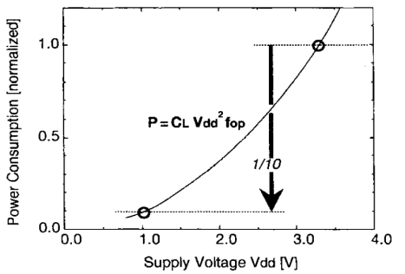
Figure 3.1 Relation between power consumption and supply voltage.

Figure 3.1 shows the relation between power consumption and supply voltage. It is apparent that lowering V_{DD} contributes to power reduction. Certainly, scaling down load capacitance or operating frequency also contributes to low-power operation. Decreasing capacitance C_{L}, however would be difficult without scaling down the device and wiring. Although there have been attempts to lower operating frequency by introducing parallel processing, this approach generally increases hardware overhead and requires extensive reworking at an architecture or algorithm design level.
- Key issue for low voltage operation
In CMOS digital circuits, the gate delay time (tpd) is approximately given by

Tpd α (C_{L}*V_{DD})/I_{DS} ≈ (C_{L}*V_{DD})/(A(V_{DD}-V_{th})²) (3.2)

Where C_{L} is the load capacitance, I_{DS} is the drain current in the saturation region, V_{DD} is the supply voltage, V_{th} is the MOSFET threshold voltage, and A is a constant. In the above expression, lowering the supply voltage decreases I_{DS} proportional to the square of the voltage difference (V_{DD}–V_{th}). Supply voltage is lowered by scaling down the device feature size to ensure the reliability of thin gate oxides. Speed performance is maintained even at low voltage due to the improvement in transconductance gm brought about by shrinking feature size to a deep submicron size. In this case, a decrease in delay time at lower voltage must be achieved without relying on device feature size scaling. One way to overcome the speed degradation problem is to reduce the V_{th} of a MOSFET [1].
- CIRCUIT DESIGN AND TECHNOLOGY CONSIDERATION
- Threshold voltage scaling
A significant power improvement can be gained through the use of low threshold MOS devices; the question of how low the thresholds can be reduced must be addressed. The limit is set by the requirement to retain adequate noise margins and the increase in sub threshold currents. Noise margins will be relaxed in low-power designs because of the reduced currents being switched, however, the sub threshold currents can result in significant static power dissipation. Essentially, sub threshold leakage occurs due to carrier diffusion between the source and the drain when the gate-source voltage, has exceeded the weak inversion point, but is still below the threshold voltage, where carrier drift is dominant. In this region, the MOSFET behaves similarly to a bipolar transistor and the sub threshold current is exponentially dependent on the gate-source voltage and approximately independent of the drain-source voltage for V_{ds} approximately larger than 0.1 V. Associated with this is the sub threshold slope, which is the amount of voltage required to drop the sub threshold current by one decade [1].

For a CMOS inverter (PMOS: W = 8pm, NMOS: W = 4 pm) the current was measured to be 64 mA over 3.7 ns at a supply voltage of 2 V. This implies that there would be a 100% power penalty for sub threshold leakage if the device were operating at a clock speed of 25 MHz with an activity factor of p = 1 /6th, i.e., the devices were left idle and leaking current 83 % of the time. It is not advisable, therefore, to use a true zero threshold device, but instead to use thresholds of at least 0.2 V, which provides for at least two orders of magnitude of reduction of sub threshold current. This provides a good compromise between improvement of current drive at low supply voltage operation and keeping sub threshold power dissipation to a negligible level. This value may have to be higher in dynamic circuits to prevent accidental discharge during the evaluation phase. Fortunately, device technologists are addressing the problem of sub threshold currents in future scaled technologies and reducing the supply voltages also serves to reduce the current by reducing the maximum allowable drain-source voltage. The design of future circuits for lowest power operation should therefore explicitly take into account the effect of sub threshold current [5].
- Voltage scaling
The reduction of supply voltage should yield even greater benefits. Reducing the supply voltage is the key to low-power operation, even after taking into account the modifications to the system architecture, which is required to maintain the computational throughput. First, a review of circuit behavior (delay and energy characteristics) as a function of scaling supply voltage and feature sizes will be presented. By comparison with experimental data, it is found that simple first-order theory yields an amazingly accurate representation of the various dependencies over a wide variety of circuit styles and architectures. A survey of two previous approaches to supply- voltage scaling is then presented, which were focused on maintaining reliability and performance. This is followed by our architecture-driven approach, from which an “optimal” supply voltage based on technology, architecture and noise margin constraints is derived.

- Optimal transistor sizing with voltage scaling
Independent of the choice of logic family or topology, optimized transistor sizing will play an important role in reducing power consumption. For low power, it is important to equalize all delay paths so that a single critical path does not unnecessarily limit the performance of the entire circuit. However, beyond this constraint, there is the issue of what extent the W/L ratios should be uniformly raised for all the devices, yielding a uniform decrease in the gate delay and hence allowing for a corresponding reduction in voltage and power. It is shown in this section that if voltage is allowed to vary, that the optimal sizing for low-power operation is quite different from that required for high speed [7].

- Optimal supply voltage
In the previous section, the delay increases due to reduced supply voltages below the critical voltage and can be compensated by exploiting parallel architectures. However, as supply voltages approach the device thresholds, the gate delays increase rapidly[6]. Correspondingly, the amount of parallelism and overhead circuitry increases to a point where the added overhead dominates any gains in power reduction from further voltage reduction, leading to the existence of an “optimal” voltage from an architectural point of view.

At very low supply voltages (near the device thresholds), the number of processors (and hence the corresponding overhead in the above equation) typically increases at a faster rate resulting in a power increase with further reduction in voltage. Reduced threshold devices tend to lower the optimal voltage. At threshold below 0.2 V, power dissipation due to the sub threshold current will soon start to dominate and limit further power improvement. An even lower bound on the power supply voltage for a CMOS inverter with “correct” functionality was found to be 0.2 V. There are a variety of considerations that must be taken into account in low-power design which include the style of logic, the technology used and the logic implemented. Factors that were shown to contribute to power dissipation included spurious transitions due to hazards and critical race conditions, leakage and direct path currents, pre-charge transitions, and power-consuming transitions in unused circuitry [5].

- ULTRA LOW VOLTAGE CMOS GATE

The Ultra Low Voltage CMOS logic is shown in Fig.5.1. The biasing or recharge transistors, marked R_{p} and R_{n} are used to set the voltage level during initialization.
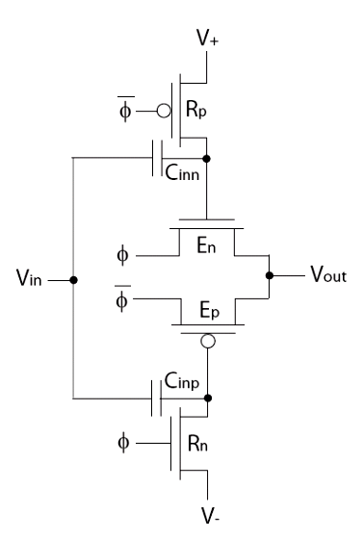

Figure 5.1 Ultra Low Voltage Inverter

When the circuit is initialized or recharged two tasks are performed in parallel:

1) The Ultra low voltage gates are biased or recharged through the biasing transistors. The NMOS Gates is biased to V_{DD} and the PMOS Gate is biased to V_{SS}. The clock drivers provide virtual references to the ULV inverter.

2) The output is pre-charged to V_{DD}/2. The time constant for the output pre-charge is much larger than the time constant for biasing the nodes. The inverter is reverse biased with a high impedance output. The output transistors E_{n} and E_{p} pull the output towards V_{DD}/2. The output voltage will depend on the previous voltage or logical level and on the time available in the initialization phase. The logic operation of the gate is not depending on the accuracy of the output pre-charge value [3].

When the gate is recharged, the PMOS will initially operate in strong inversion due to an effective voltage V_{eff} = V_{G}−V_{S}−V_{T} ≈ (5/4)V_{DD}−V_{T} . When the reference voltages starts the transition to reverse biased mode the output of the gate (ULV) will be at a potential below both references, hence the transistor currents through E_{p} and E_{n} will be positive seen from the output and thus pull the output quickly towards V_{DD}/2. If the output is equal to V_{DD} at the start of the recharge period, due to a negative input transition, both output transistors E_{n} and E_{p} will contribute pulling the output quickly towards V_{DD}/2. The biasing delay for the output is larger because the output transistors are reverse biased and the output impedance is low. Preliminary data suggest that a ULV inverter is able to respond correctly to a input transition less than 40 mV [4]. The gate drain capacitance will degrade the performance through a reduced Tranconductance and gain. Transistor mismatches, i.e. threshold voltage variations, will also affect the recharge output value of the ULV gate. If the NMOS Gate, E_{n} is strong compared to E_{p} the output recharge level will settle at a voltage higher than V_{DD}/2 [3].

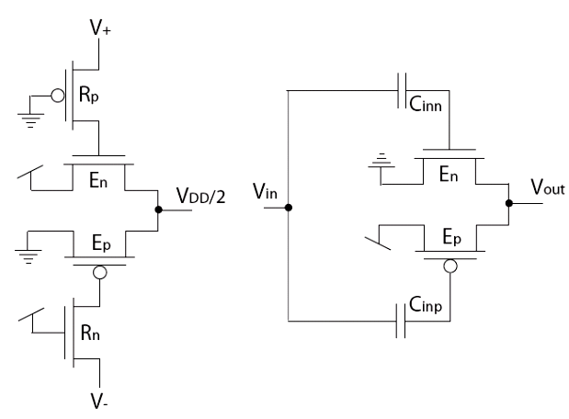
Figure 5.2 Simplified Ultra low voltage recharge inverter in
a) recharge mode and b) evaluate mode

where R_{p} , R_{n} are the Recharge transistor and E_{n} , E_{p} are the evaluate transistor.
The PMOS Clocked transistor is obtained using a PMOS evaluate transistor and a NMOS recharge transistor. The clock drivers which provide both the control signals and the reference signals in the evaluation phase is included. The effective supply voltage is determined by the clock signal φ and the recharge voltages V+ and V− regulate the current level. The ULV logic style resembles domino logic [8]. The output of the ULV gate will always be driven and less susceptible to noise than dynamic domino logic. The ULV inverter in recharge and evaluate mode is shown in Figure 5.2.

The ULV gate operation is characterized by:

• Recharge. The simplified ULV inverter in recharge mode is shown in Figure 5.2 (a). The NMOS Gate is recharged to V+ and the PMOS Gate is recharged to V− while the output and input are precharged to V_{DD}/2. The output will be forced to V_{DD}/2 due to a reversed biased inverter.

• Evaluate. The simplified ULV inverter in evaluate mode is shown in Figure 5.2 (b). The output will be pulled to V_{DD}/2 if a negative transition ΔV_{in} = −V_{DD}/2 occurs and to GND if there is a positive transition ΔV_{in} = V_{DD}/2, applied at the input.
A low voltage and high speed configuration is achieved if a high offset voltage V+ and V− = V_{DD}−V+ is applied. The ULV inverter will not be recharged as fast as the low voltage and high speed ULV inverter due to the reduced currents running through the recharge transistors. Both the evaluate response and the recharge response will be slower together with the dynamic and static power consumption. The recharge current is determined by a effective bias of the recharge transistors. The accuracy of the pre-charge level is not significant for an inverter gate, however if more complex gates with higher fan-in is required the pre-charge level need to be close to V_{DD}/2.

- SIMULATION RESULT

- Design of Ultra low voltage inverter

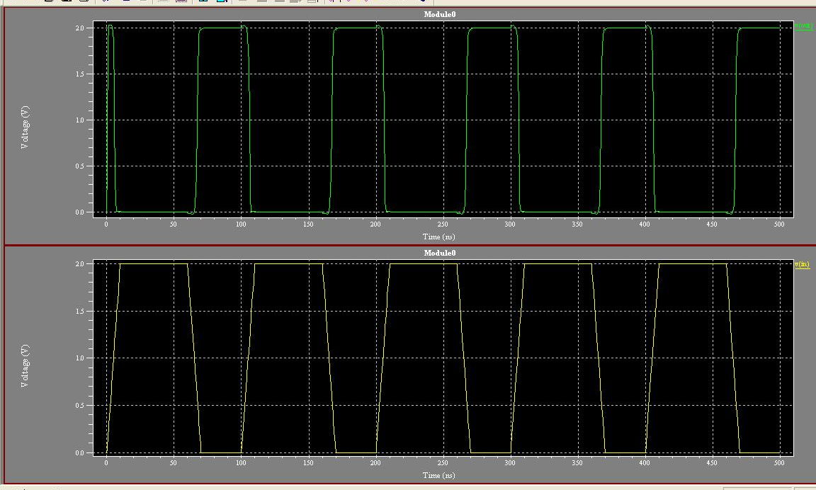T
Figure 6.1 Output waveform for Ultra low voltage inverter

It has been found that the power consumed by a complementary inverter using Tanner EDA Tool was 1.901631 e-004 and the power consumed by the Ultra low voltage inverter was 7.112237e-008. It is proved that the use of Ultra low voltage inverter in design rather than a complementary inverter would save power by 5.2106e⁻⁰⁰¹.The output waveform is shown for the corresponding input waveform as shown in the above figure respectively

- Design of XOR gate using Ultra low voltage inverter

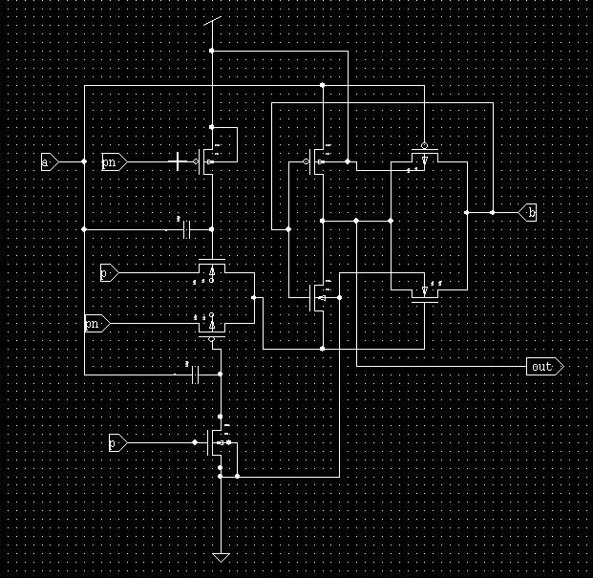
Figure 6.2 Schematic diagram of XOR Gate in Tanner

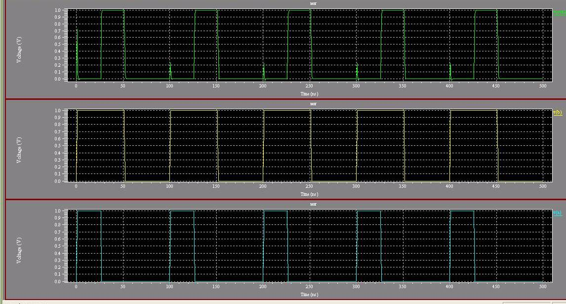

Figure 6.3 Output waveform for a XOR gate using Ultra Low Voltage inverter

It has been found that the power consumed by a XOR gate using complementary inverter in Tanner EDA Tool was 1.761627e-005 and the power consumed by the XOR gate using Ultra low voltage inverter was 5.474853e-007. The output waveform is shown for the corresponding input waveform as shown in the above figure respectively.
- Design of AND gate using Ultra low voltage inverter

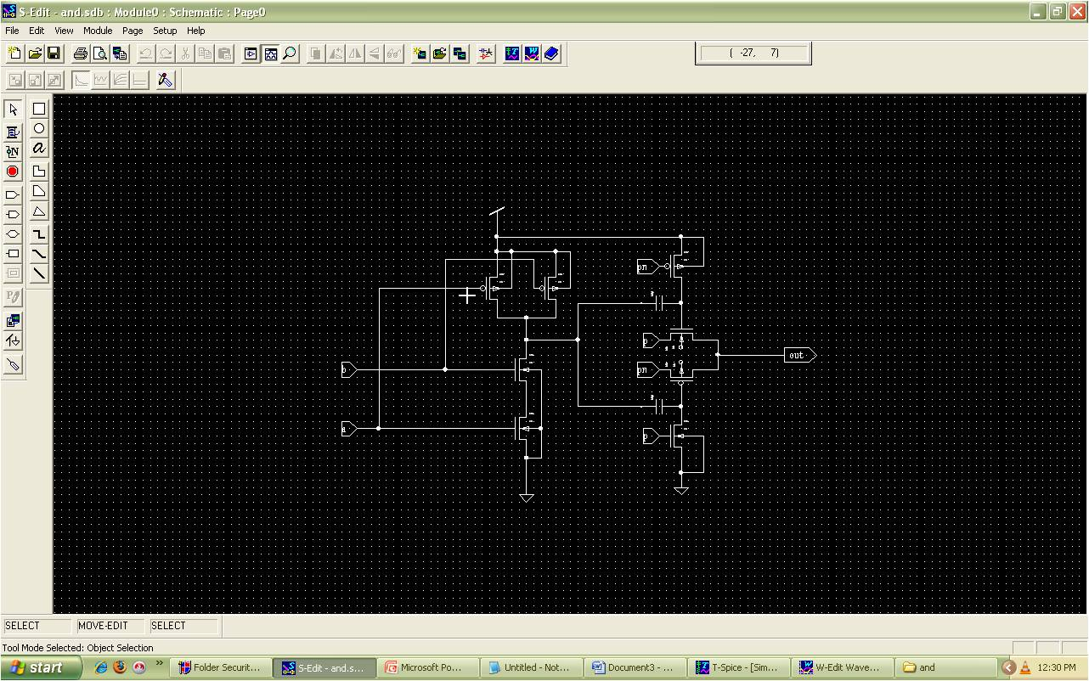

Figure 6.4 schematic diagram of AND gate

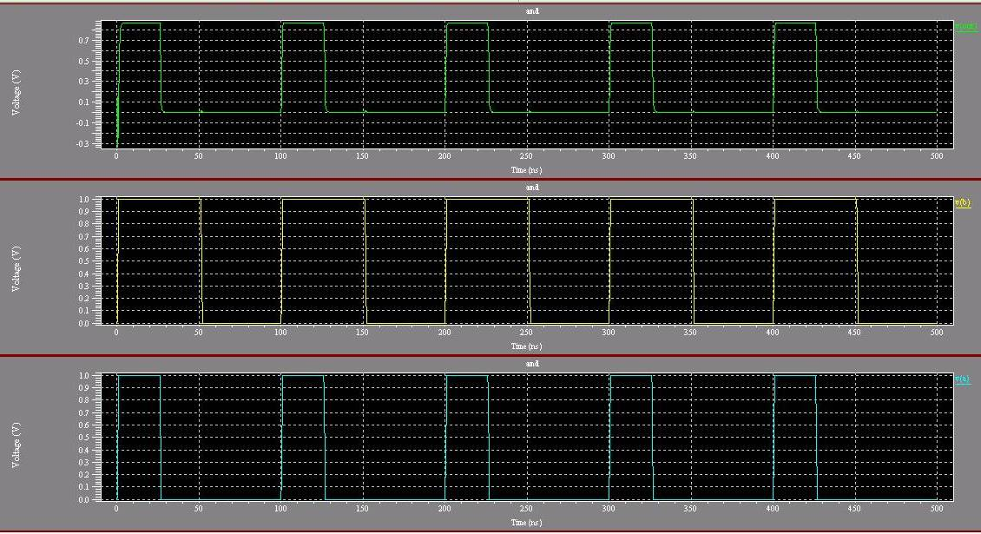

Figure 6.5 Output waveform for AND gate using Ultra low voltage inverter

It has been found that the power consumed by a AND gate using complementary inverter in Tanner EDA Tool was 4.369137e-005 and the power consumed by the AND gate using Ultra low voltage inverter was 1.616528e-005. The output waveform is shown for the corresponding input waveform as shown in the above figure respectively.
- Design of Ultra low voltage inverter
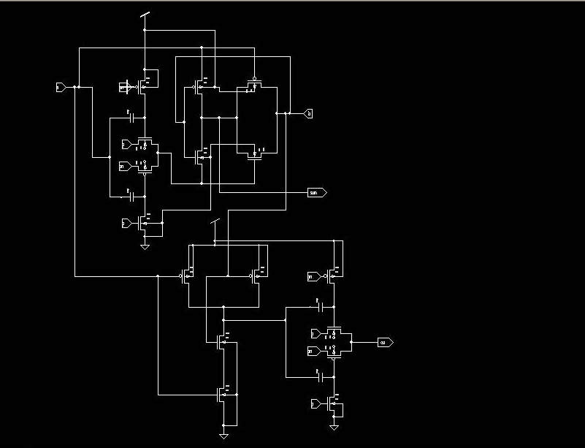

Figure 6.6 schematic diagram of half adder using Ultra low voltage inverter in Tanner

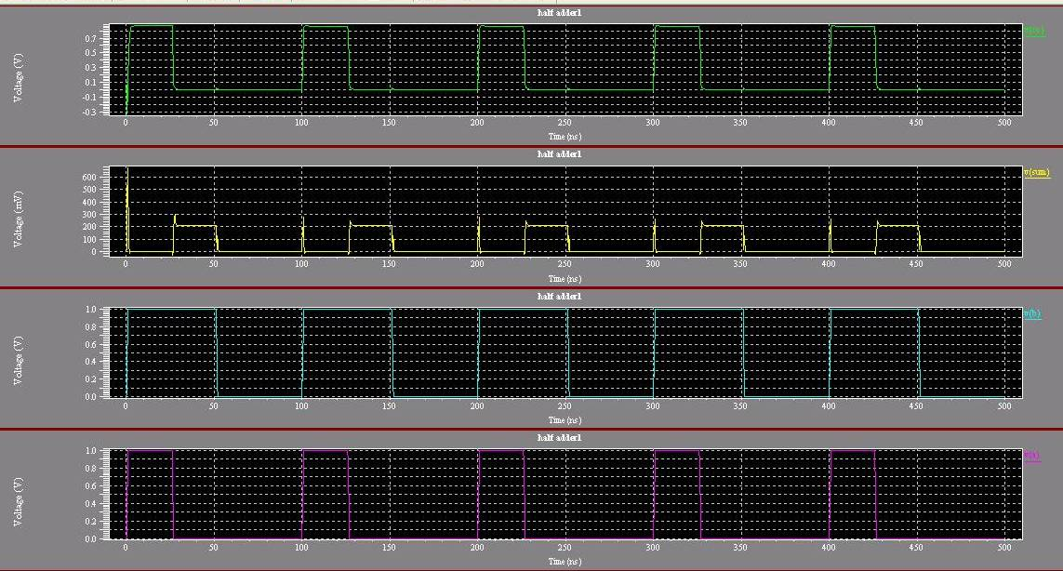

Figure 6.7 Output waveform for half adder using Ultra low voltage inverter
- Design of OR gate using Ultra low voltage inverter
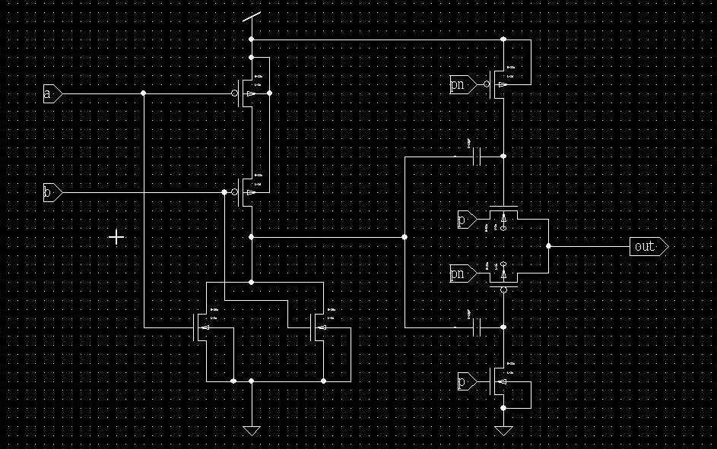

Figure 6.8 Schematic diagram of OR gate in Tanner

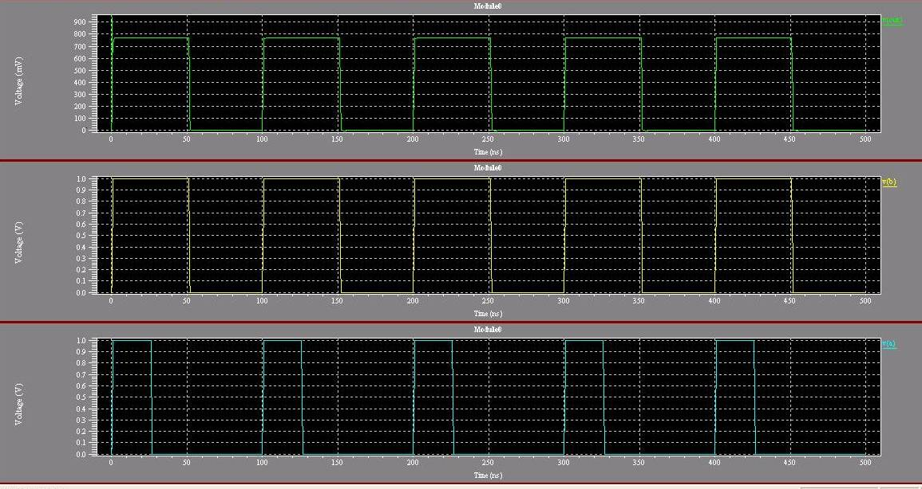

Figure 6.9 Output waveform for OR gate

It has been found that the power consumed by a OR gate using complementary inverter in Tanner EDA Tool was 3.460128e-005 and the power consumed by the XOR gate using Ultra low voltage inverter was 7.301789e-007 . The output waveform is shown for the corresponding input waveform as shown in the above figure respectively.
- Design of Full adder using Ultra low voltage inverter

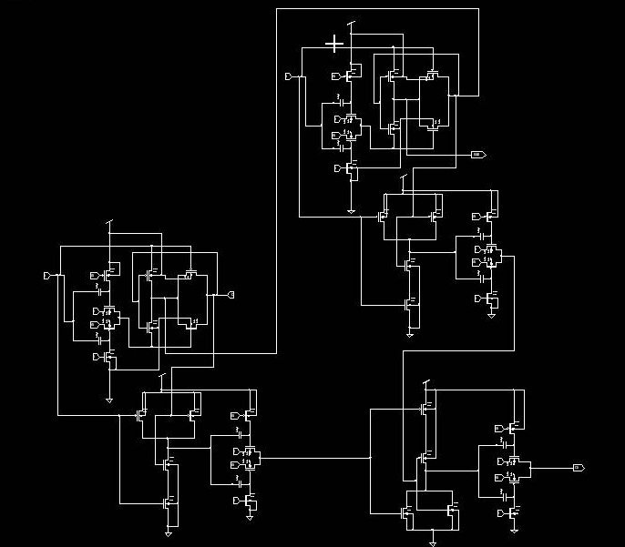

Figure 6.10 Schematic diagram of full adder
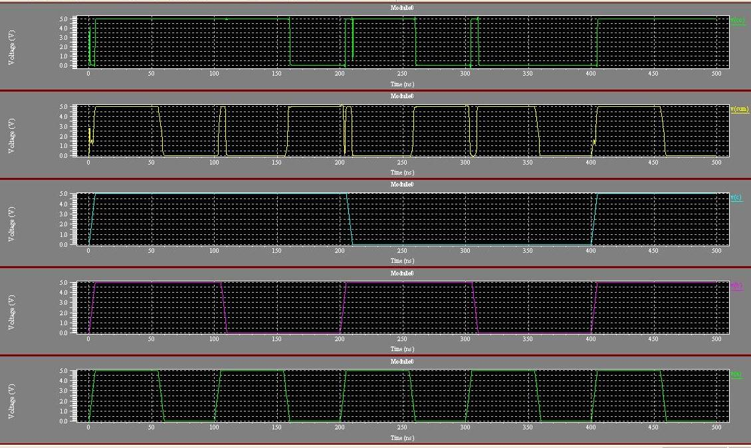

Figure 6.11 Output waveform for full adder using two half adder

It has been found that the power consumed by a Full adder gate using complementary inverter in Tanner EDA Tool was 5.334652 e-004 and the power consumed by the Full adder using Ultra low voltage inverter was 2.84582e⁻⁰⁰⁴. The output waveform is shown for the corresponding input waveform as shown in the above figure respectively.

- Conclusions
The performance of the ultra low voltage (ULV) logic style is compared to a complementary inverter. The complementary inverter is designed using Tanner EDA Tool and its power consumption is measured. The total power dissipation which is the combination of static power dissipation and dynamic power dissipation is reduced by scaling the threshold voltage along with the supply voltage. This complementary inverter is used as the basic module for the design of the full adder and its power consumption is measured. Similarly, the Ultra Low Voltage Inverter is designed using Tanner EDA Tool and its power consumption is measured. It is proved that the power consumed by the Ultra Low Voltage Inverter is low compared to that of the complementary inverter. This shows that the use of the Ultra Low Voltage Inverter as a basic module in any design would result in low power consumption compared to that of a complementary inverter. The ULV logic gates can be utilized to design fast systems operating at ultra low supply voltages. The simulated data presented is obtained using the Tanner EDA Tool and executed for a 90nm CMOS process. The dynamic power consumption is reduced significantly with reduced supply voltage. Thus the Ultra Low Voltage Inverter is configured to operate at low power compared to that of a complementary inverter.
References
- Aoki .T, Douseki.T, Matsuya Y, Mutoh S and Shigematsu S(1995), “1-V power supply high-speed digital circuit technology with multi threshold-voltage CMOS” IEEE Journal of Solid-State Circuits, Volume 30, Issue 8.
- Aunet.S, Berg.Y and Mirmotahari.O (2003),“Novel Recharge Semi-Floating-Gate CMOS Logic for Multiple-Valued Systems”, In IEEE International Symposium on Circuits and Systems (ISCAS), Bangkok
- Aunet.S, Berg.Y, Mirmotahari.O and Norseng.P.A(2006), “Ultra Low Voltage CMOS gates”, In Proc. IEEE International Conference on Electronics, Circuits and Systems , France.
- Berg.Y, Lande.T.S and Wisland.D.T(1999), “Ultra Low Voltage/Low-Power Digital Floating-Gate Circuits”, IEEE Transactions on Circuits and Systems, vol. 47, No. 7, pp. 930–936.
- Brodersen.R.W, Chandrakasan.A.P and Sheng.S.(1992),“Low-power CMOS digital design” , IEEE Journal of Solid-State Circuits, Volume 27, Issue 4.
- Harry Veendrick J.M.(1984),”Short Circuit Dissipation of Static CMOS Circuitry and Its Impact on the Design of Buffer Circuits”, IEEE Journal of solid state circuits,vol. sc-19,no. 4.
- Horowitz.M and Usami.K (1995), “Clustered voltage scaling technique for low-power design”, International Symposium on Low Power Electronics and Design.
- Omid Mirmotahari and Yogvar Berg(2009),”Low Voltage Pre-charge CMOS Logic“, IEEE Transaction on Circuits and SYSTEMS—II: Analog and Digital Signal Processing, Vol. 46, no. 7.

