Face Recognition Using Enhanced Fisher Model

Ms.C.Thangathai¹ Ms.R.Beulah Jeyavathana²
Post Graduate Student Assistant Professor/CSE

Department of Computer Science and Engineering Department of Computer Science and Engineering
Mepco Schlenk Engineering College Mepco Schlenk Engineering College
Virudhunagar (Dist), Sivakasi. Virudhunagar (Dist), Sivakasi.
Email:thangathai.c@gmail.com Email:beulahvathana@yahoo.com

Abstract— A new hybrid Color and Frequency Features (CFF) method for face recognition is proposed. The CFF method, which applies an Enhanced Fisher Model (EFM), extracts the complementary frequency features in a new hybrid color space for improving face recognition performance. The new color space, the RIQ color space, which combines the component image of the RGB color space and the chromatic components and of the YIQ color space, displays prominent capability for improving face recognition performance due to the complementary characteristics of its component images. The EFM then extracts the complementary features from the real part, the imaginary part, and the magnitude of the image in the frequency domain. The complementary features are then fused by means of concatenation at the feature level to derive similarity scores for classification. The complementary feature extraction and feature level fusion procedure applies to the I and Q component images as well. Another work for Fisher Linear Discriminent method for face recognition.The FLD method is able to further improve face recognition performance.

Index Terms- Enhanced fisher model EFM), face recognition grand challenge (FRGC), the RIQ color space, Fisher Linear Discriminent method.
.
- INTRODUCTION
The controlled images were taken in a studio setting, are full frontal facial images taken under two lighting conditions (two or three studio lights) and with two facial expressions (smiling and neutral).The uncontrolled images were taken in varying illumination conditions. e.g., hallways, atria, or outdoors. This approach for face recognition one that is insensitive to large variations in lighting and facial expressions. The Face Recognition Grand Challenge (FRGC) program reveals that uncontrolled illumination conditions pose grand challenges to face recognition performance [7]. The color information and frequency features derived by means of the Discrete Fourier Transform help improve face recognition performance

A new Hybrid Color and Frequency Features (CFF) method for face recognition is proposed. A new color face(RIQ),which combines the R component image of the RGB color space and chromatic components I and Q of the

YIQ color space, displays prominent capability for improving face recognition performance due to the complementary characteristics of its component images. The Enhanced Fisher Model (EFM) [5] then extracts the complementary features from real part and imaginary part and the magnitude part of the R image in the frequency domain, Note that in the frequency domain, a frequency set selection method is applied to derive the complementary frequency features that have different discriminating power for face recognition. The complementary features are then fused by means of concatenation at the feature level to derive similarity scores for classification. The complementary feature extraction and feature level fusion procedure applies to the I and Q component image as well. The similarity scores derived from the R, I and Q images are finally fused by means of a weighted summation at the decision level for face recognition.

II. PROPOSED SYSTEM
The combination of the hybrid color and frequency features by the CFF method is able to further improve face recognition performance. A new hybrid color space, the RIQ color space, where R is from the RGB color space and I and Q are from the YIQ color space. Hybrid color and frequency features (CFF) method derives the complementary features in the frequency domain from the component images in the RIQ color space

A. CFF method
The CFF method, applies an Enhanced Fisher Model (EFM), extracts the complementary frequency features in a new hybrid color space RIQ. The EFM extracts the complementary frequency features using different mask in the frequency domain from the R, I, and Q component images.

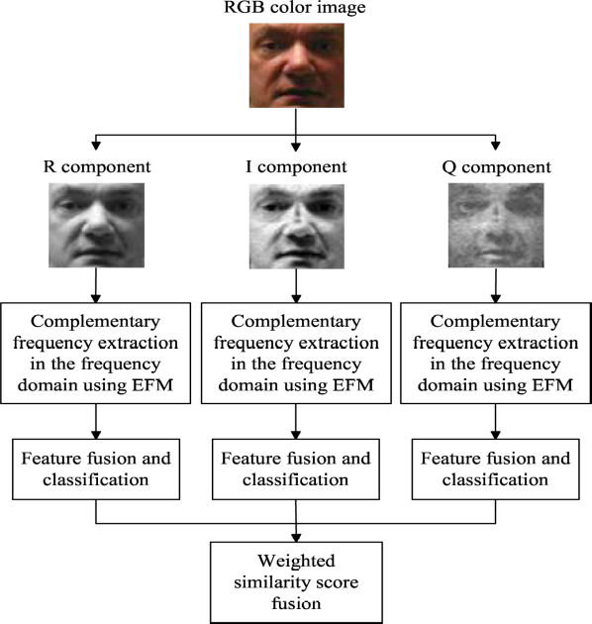
Fig .1.system architecture of the CFF method.

The complementary features are fused at the feature level to derive similarity scores for classification. The similarity scores derived from the R, I, and Q images are fused together at the decision level for face recognition.
B.Frequency set selection in the hybrid color space 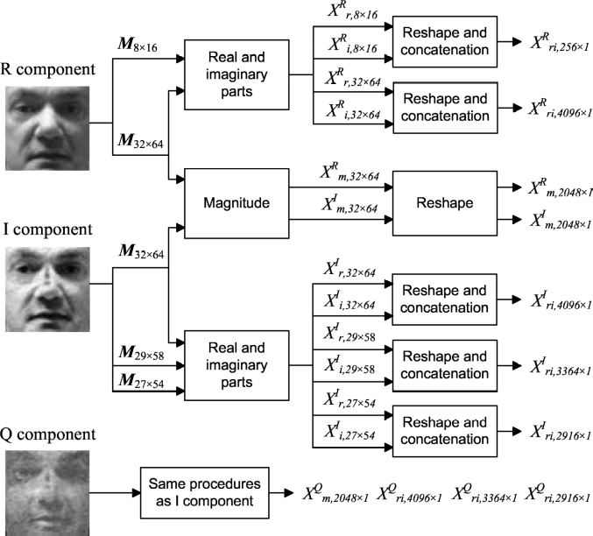
Fig 2 Frequency pattern vectors by means of frequency set selection in the hybrid color space.

Fourier Transform of a face image consist of real part(log plot),the imaginary part, and the magnitude(log plot). A mask is used to extract the face information in the Fourier domain. The face images in our research have the spatial resolution of 64*64,the real part, the imaginary part, and the magnitude in the frequency domain have the same resolution of 64*64. In the hybrid color space, the R, I, and Q component images apply some different masks to extract their frequency features, respectively, Fig. 2 specifies the following components,

1.R component image
R component image first two applies two mask,M8*16 and M 32*64 to extract the frequency feature from real and imaginary part. Next utilize the mask M32*64 to extract the frequency feature from magnitude in the frequency domain. The frequency feature extracted corresponding to these mask are X^{R}_{r} 8*16, X^{R}_{i} 8*16, X^{R}_{r} 32*64, X^{R}_{i} 32*64, and X^{R}_{m} 32*64.
2. I component image
I component image first apply three mask, M32*64, M29*58, M27*54 to extract the frequency feature from real and imaginary part, and then apply the mask, M32*64 to extract the frequency feature from magnitude in the frequency domain. The frequency features extracted corresponding to these masks are X^{I}_{r} 32*64, X ^{I}_{i} 32*64, X^{I}_{r} 29*58, X^{I}_{i} 29*58, X^{I}_{r} 27*54, X^{I}_{i} 27*54 and X^{I}_{m}32*64.
3 .Q component image
I component image first apply three mask,M32*64, M29*58, M27*54 to extract the frequency feature from real and imaginary part, and then apply the mask, M32*64 to extract the frequency feature from magnitude in the frequency domain. The frequency features extracted corresponding to these masks are X^{I}_{r} 32*64, X ^{I}_{i} 32*64, X^{I}_{r} 29*58, X^{I}_{i} 29*58, X^{I}_{r} 27*54, X^{I}_{i} 27*54 and X^{I}_{m}32*64.

4.Feature Concatenation
Reshape and concatenating the real and imaginary features, we have three frequency pattern vectors resulting from the R component image X ^{R}_{ri} 256*1, X ^{R}_{ri} 4096*1, and X^{R}_{m}2048*1.
Reshape and concatenating the real and imaginary features, we have four frequency pattern vectors resulting from the I component image X ^{I}_{ri} 4096*1, X ^{I}_{ri} 3364*1, X _{ri}2916*1, and X ^{I}_{m}2048*1.
Reshape and concatenating the real and imaginary features, we have four frequency pattern vectors resulting from the I component image X ^{I}_{ri} 4096*1, X ^{I}_{ri} 3364*1, X ^{I}_{ri}2916*1,and X ^{I}_{m}2048*1

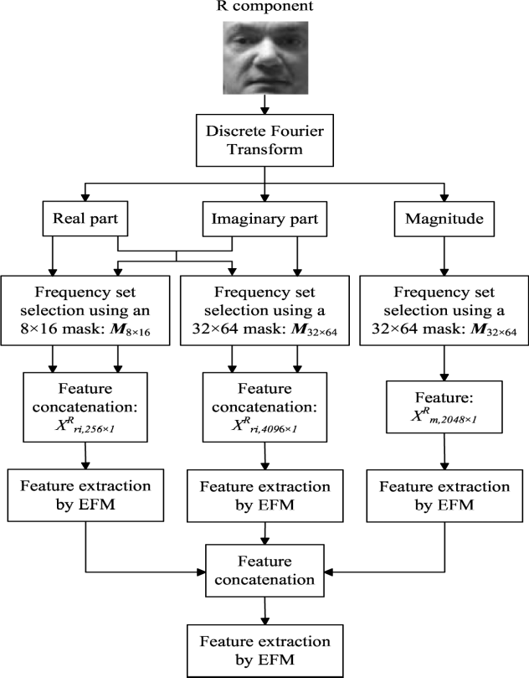
fIg 3 The hybrid color and frequency feature extraction, fusion, and classification for the R component image using the EFM method

C. Hybrid color and Frequency Feature Extraction using EFM method
The frequency pattern vectors derived in the hybrid color space are further processed using the EFM method to extract hybrid color and frequency feature extraction
1. Enhanced FLD Models (EFM)
We present in this section two EFM’s in order to improve the generalization capability of FLD based classifiers. Similar to Fisher faces, both EFM models (EFM-1 and EFM-2) apply first PCA for dimensionality reduction before proceeding with FLD analysis. EFM-1 implements the dimensionality reduction with the goal to balance between the need that the selected eigenvalues account for most of the spectral energy of the raw data and the requirement that the eigenvalues of the within-class scatter matrix in the reduced PCA space are not too small. EFM-2 implements the dimensionality reduction as the Fisher faces method does. It proceeds then with the whitening of the within-class scatter matrix in the reduced PCA space and then chooses a small set of features (corresponding to the eigenvectors of the within-class scatter matrix) so that the smaller trailing eigenvalues are not included further in the computation of the between-class scatter matrix.
2 . Fisher linear discriminant (FLD)
The FLD is a widely used technique for feature selection. Let w1,w2,….w_{L} and N1,N2,….N_{L} denote the classes and the number of images within each class, respectively. L is the number of the classes. Let M1,M2,…M_{L}be the means of the classes and the grand mean. Let 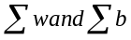 be the within- and between-classscatter matrices. The standard FLD procedure derives a projection  matrix that maximizes the ratio |Ψ^{T} 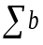Ψ| /|Ψ ^{T}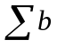 Ψ.This ratio is maximized when consists of the eigenvectors of the matrix 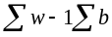
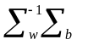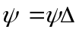. .(1)
Where 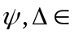R^{N*N} are the Eigen vector and eigen value matrics are of 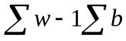.
3. EFM-1
First whiten the within-class scatter matrix
^{-1/2t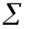’}_{w-}^{1/2}=I (2)
Where 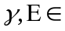R^{m*m} are the eigenvalue and eigen vector metrics of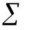’_{w}
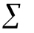’_{w}=and^{t}=I (3)
After the number of principle components is set,EFM-1 computes between-class scatter matrix k_{b} as
k_{b}= ^{-1/}2 ^{t’}_{b-}^{1/2} (4)
Diagonalize the new between-class scatter matrix k_{b}
k_{b}^{t}  (5)
The overall transformation matrix(in the reduced PCA space )for EFM-1 is now defined as
T=^{-1/2} (6)
4.EFM-2
The EFM-2 proceeds then by choosing a small set of features after the whitening procedure so that the smaller trailing eigenvalues are not included.
Let s(s<m) be the number of features chosen in the whitening space according to the Eigen value spectrum of ’_{w,} and a new projection matrix *R^{m*s} is derived
*=[_{12……….,s}] (7)
where _{12……….,s} are the eigen vectors of’_{w} corresponding to the leading eigenvalues _{1,} _{2…..s.} the new diagonal matrix is
*=diag {_{1,2…..s.}} (8)
The new whitening transformation matrix in the reduced s dimensional whitened space is
Q=(*)(*)-^{1/2} (9)
The between-class scatter matrix _{Kb} in this space is transformed to k_{b}*
k_{b}*=Q^{t}_{b}Q (10)
Note that the new between-class scatter matrix k_{b}* is s*s now instead of m*m.Diagonalize k_{b}*
k_{b}**=**and *^{t}*=I (11)
The overall transformation matrixforEFM-2 is
T*=**^{-1/2} (12)
Fig.3. shows the hybrid color and frequency feature extraction, fusion, and classification for the component image using the EFM method. Specifically, after the frequency set selection and feature concatenation, we have three frequency pattern vectors resulting from the R component image: X^{R}_{ri,256*1,} X^{R}_{ri,4096*1,}X^{R}_{m,2048*1} These frequency pattern vectors are then processed by the EFM to extract the low-dimensional EFM features. The three EFM feature vectors are fused by means of concatenation to form another feature vector. This fused EFM feature vector is further processed by the EFM to derive the final feature vector for the computation of the similarity scores.
No of Test image | No of train image | Face verification Rate
50 | 25 | 36%
25 | 50 | 96%
50 | 100 | 94%
100 | 50 | 42%
100 | 200 | 97%
200 | 100 | 66.5%
150 | 300 | 100%
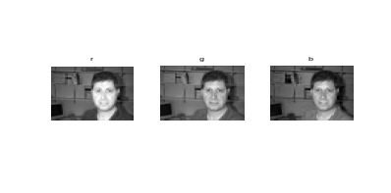
III. Results

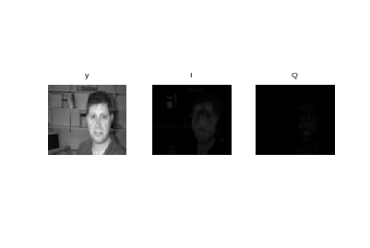
Fig..a. color component images in the RGB color space

Fig. b.. Color component images in the YIQ color space

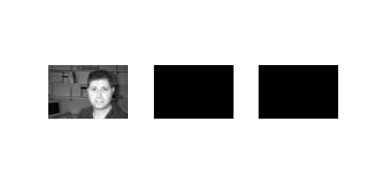
R I Q

Fig.. c. color component image in the RIQ color space

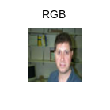
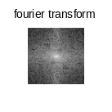
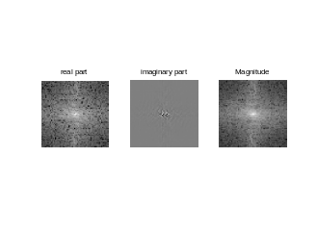
RGB component images converted into RGB to YIQ.A new hybrid color space, the RIQ color space, where R is from the RGB color space and I and Q are from the YIQ color space

Fig..d. Fourier Transform of a face image consists of real part (log plot), the imaginary part, and the magnitude (log plot). A mask is used to extract the face information in the Fourier domain

Fourier transform of a R component: the real part(log plot),and the imaginary part, and the magnitude (log plot).Hybrid color space, the R,I and Q component images apply some different mask to extract the frequency features.


Fig.e
Image which matched among the training images

Table 1. Recognition rate for different test and trainimage

Table 2.Comparision of FLD and EFM method
Proposed method | Face Recognition rate
FLD method | 85%
EFM method | 90%

IV.CONCLUSION
This paper presents a novel hybrid Color and Frequency Features (CFF) method for face recognition.. Future research will consider applying kernel methods, such as the multiclass Kernel Fisher Analysis (KFA) method, to replace the EFM method for improving face recognition performance.
V. REFERENCES
[1] P. N. Belhumeur, J. P. Hespanha, and D. J. Kriegman, “Eigenfaces vs.Fisherfaces: Recognition using class specific linear projection,” IEEETrans. Pattern Anal. Mach. Intell., vol. 19, no. 7, pp. 711–720, Jul.1997.
[2] V. Kumar, M. Savvides, and C. Xie, “Correlation pattern recognition for face recognition,” Proc. IEEE, vol. 94, no. 11, pp. 1963–1976, Nov.2006.
[3] C. Liu, “Capitalize on dimensionality increasing techniques for improving face recognition grand challenge performance,” IEEE Trans.Pattern Anal. ach. Intell., vol. 28, no. 5, pp. 725–737, May 2006.
[4] C. Liu, “The Bayes decision rule induced similarity measures,” IEEE Trans. Pattern Anal. Mach. Intell., vol. 29, no. 6, pp. 1086–1090, Jun.2007.
[5] C. Liu and H. Wechsler, “Robust coding schemes for indexing and retrieval from large face databases,” IEEE Trans. Image Process., vol. 9,no. 1, pp. 132–137, Jan. 2000.
[6] A. J. OToole, P. J. Phillips, F. Jiang, J. Ayyad, N. Penard, and H. Abdi,“Face recognition algorithms surpass humans matching faces across changes in illumination,” IEEE Trans. Pattern Anal. Mach. Intell., vol.29, no. 9, pp. 1642–1646, Sep. 2007.

